STOCKER
[UDP]

A Project Report Submitted by

Kanan Anadkat-171160107002
Hetvi Gandhi-171160107018
Pranav Joshi-171160107029
Brijesh Shukla-171160107052

in partial fulfilment for the award of the degree of

Bachelor of Engineering
in
Computer Engineering



Marwadi Education Foundation-Faculty of PG Studies
& Res. In Engineering & Technology, Rajkot

Gujarat Technological University, Ahmedabad
2020-21

Marwadi Education Foundation-Faculty of PG Studies
& Res. In Engineering & Technology, Rajkot
Computer Engineering Department
2020-21

CERTIFICATE

This is to certify that the project entitled Stocker has been carried out by Kanan Anadkat-171160107002 under my guidance in partial fulfilment of the degree of Bachelor of Engineering in Computer Engineering of Gujarat Technological University, Ahmedabad during the academic year 2019-20.

Date: ____________________

Internal Guide Head of the Department

Prof. Shaktirajsinh Jadeja Prof. Jay Teraiya
Assistant Professor Head of Department

Marwadi Education Foundation
Faculty of [Engineering/Technology/PG Studies]
Computer Engineering Department
2020-21

CERTIFICATE

This is to certify that the project entitled Stocker has been carried out by Hetvi Gandhi-171160107018 under my guidance in partial fulfilment of the degree of Bachelor of Engineering in Computer Engineering of Gujarat Technological University, Ahmedabad during the academic year 2020-21.

Date: ____________________

Internal Guide Head of the Department

Prof. Shaktirajsinh Jadeja Prof. Jay Teraiya
Assistant Professor Head of Department

Marwadi Education Foundation
Faculty of [Engineering/Technology/PG Studies]
Computer Engineering Department
2020-21

CERTIFICATE

This is to certify that the project entitled Stocker has been carried out by Pranav Joshi-171160107029 under my guidance in partial fulfilment of the degree of Bachelor of Engineering in Computer Engineering of Gujarat Technological University, Ahmedabad during the academic year 2020-21.

Date: ____________________

Internal Guide Head of the Department

Prof. Shaktirajsinh Jadeja Prof. Jay Teraiya
Assistant Professor Head of Department

Marwadi Education Foundation
Faculty of [Engineering/Technology/PG Studies]
Computer Engineering Department
2020-21

CERTIFICATE

This is to certify that the project entitled Stocker has been carried out by Brijesh Shukla-171160107052 under my guidance in partial fulfilment of the degree of Bachelor of Engineering in Computer Engineering of Gujarat Technological University, Ahmedabad during the academic year 2020-21.

Date: ____________________

Internal Guide Head of the Department

Prof. Shaktirajsinh Jadeja Prof. Jay Teraiya
Assistant Professor Head of Department

Undertaking about Originality of Work
We hereby certify that we are the sole authors of this UDP project report and that neither any part of this UDP project report nor the whole of the UDP Project report has been submitted for a degree by other student(s) to any other University or Institution.
We certify that, to the best of our knowledge, the current UDP Project report does not infringe upon anyone’s copyright nor violate any proprietary rights and that any ideas, techniques, quotations or any other material from the work of other people included in our UDP Project report, published or otherwise, are fully acknowledged in accordance with the standard referencing practices. Furthermore, to the extent that we have included copyrighted material that surpasses the boundary of fair dealing within the meaning of the Indian Copyright (Amendment) Act 2012, we certify that we have obtained a written permission from the copyright owner(s) to include such material(s) in the current UDP Project report and have included copies of such copyright clearances to our appendix.
We have checked the write up of the present UDP Project report using anti-plagiarism database and it is in the allowable limit. In case of any complaints pertaining to plagiarism, we certify that we shall be solely responsible for the same and we understand that as per norms, University can even revoke BE degree conferred upon the student(s) submitting this UDP Project report, in case it is found to be plagiarised.
Team:

Enrolment Number | Name | Signature
171160107002 | Kanan Anadkat | Kanan Anadkat
171160107018 | Hetvi Gandhi | Hetvi Gandhi
171160107029 | Pranav Joshi | Pranav Joshi
171160107052 | Brijesh Shukla | Brijesh Shukla

Place: _____________ Date: _____________
Acknowledgments
We would like to extend our hearty thanks with a deep sense of gratitude and respect to all those who provides us immense help and guidance during our project.
We would like to thank our Head of Department for providing a vision about the system. We have been greatly benefited from their regular critical reviews and inspiration throughout my work.
We would like to express our sincere thanks to our internal guide Prof. Shaktirajsinh jadeja and who gave us an opportunity to undertake such a challenging and great innovative work. We are grateful to them for their guidance, encouragement, understanding and insightful support in the development process.
Last but not the least we would like to mention here that we are greatly indebted to each and everybody who has been associated with our project at any stage but whose name does not find a place in this acknowledgement.

INDEX
Pg. NO
Institute’s Vision and Mission IV

Department’s Vision and Mission X

PEO, POs and PSOs XI-XIII

Abstract XIV

List of Figures XV-XVI

- Introduction 1-3

1.1 Problem summary and Introduction 1 1.2 Aim and Objectives 1
1.3 Problem Specification 1
1.4 Plan of Work 2
1.5 Materials / Tools Required 3

- Analysis, Design Methodology And Implementation Strategy 4-15

2.1 Ideation Canvas 4-5
2.2 Product Development Canvas 6-8
2.3 Database Overview 8-9
2.4 System Design 10-15

- Implementation 16-24

3.1 Implemented Functionality 16
3.2 Results and Reports 16-18
3.3 Snapshots 18-22
3.4 Testing and Verification 23-24

- Conclusion 25-27

4.1 Summary of the Results 25
4.2 Advantages of your work/result/methodologies 25
4.3 Scope of future work 25
4.4 Attainment of POs and PSOs 26-27

Appendix A – Business Model Canvas (BMC) 28-30

Appendix B – Periodic Progress Reports (PPR) 31-38

Appendix C - Patent Drafting Exercise (PDE) 39-43

Appendix D – Plagiarism Report 44

Institute’s Vision and Mission
Institute’s Vision
Our vision is to address challenges facing our society and planet through sterile education that builds capacity of our students and empower them through their innovative thinking practice and character building that will ultimately manifest to boost creativity and responsibility utilizing the limited natural resources to meet with the challenges of the 21st century.
Institute’s Mission
- To Produce creative, responsible and informed professionals
- To produce individuals who are digital-age literates, inventive thinkers, effective communicators and highly productive.
- To deliver cost-effective quality education
- To offer world-class, cross-disciplinary education in strategic sectors of economy though well devised and synchronized delivery structure and system, designed to tackle the creative intelligence and enhance the productivity of individuals.
- To provide a conducive environment that enables and promotes individuals to creatively interact, coordinate, disseminate and examine change, opinion as well as concept that will enable students to experience higher level of learning acquired through ceaseless effort that lead to the development of character, confidence, values and technical skills.
Department’s Vision and Mission
Department’s Vision
To impart quality technical education through research, innovation and teamwork for creating professionally superior and ethically strong manpower that meet the global challenges of engineering industries and research organization in the area of Computer Engineering.
Department’s Mission
- Maintain a vital, state-of-the art ICT enabled teaching and learning methodologies, which provides its students and faculty with opportunities to create, interpret, apply and disseminate knowledge.
- Enable graduates in becoming digital age literates, innovators, efficient communicators and result oriented professionals.
- Dedicate itself to providing its students with the skills, knowledge and attitudes that will allow its graduates to succeed as engineers, leaders, professionals and entrepreneurs.
- Prepare its graduates for life-long learning to meet intellectual, ethical and career challenges.
- Inspire graduates for competitive exam higher education as well as research and development.
PEO, PO and PSO
Program Educational Objectives (PEO):
The program educational objectives for the Computer Engineering program describe accomplishments that graduates are expected to attain within four years after graduation. The Computer Engineering program educational objectives are to produce graduates who:
- Function and communicate effectively to solve technical problems.
- Advance professionally to roles of greater computer engineering responsibilities, and/or by transitioning into leadership position in business, government, and/or education.
- Participate in life-long learning through the successful completion of advanced degrees, continuing education, and/or engineering certification(s)/licensure or other professional development.
- Demonstrate a commitment to community by applying technical skills and knowledge to support various service activities.
- Assume positions of leadership and responsibility within an organization and progress through advanced degree or certificate programs in engineering, business, and other professionally related fields.
Program Outcomes (POs)
Engineering Graduates will be able to:
PO1: Engineering knowledge: Apply the knowledge of mathematics, science, engineering fundamentals, and an engineering specialization to the solution of complex engineering problems.
PO2: Problem analysis: Identify, formulate, review research literature, and analyze complex engineering problems reaching substantiated conclusions using first principles of mathematics, natural sciences, and engineering sciences.
PO3: Design/development of solutions: Design solutions for complex engineering problems and design system components or processes that meet the specified needs with appropriate consideration for the public health and safety, and the cultural, societal, and environmental considerations.
PO4: Conduct investigations of complex problems: Use research-based knowledge and research methods including design of experiments, analysis and interpretation of data, and synthesis of the information to provide valid conclusions.
PO5: Modern tool usage: Create, select, and apply appropriate techniques, resources, and modern engineering and IT tools including prediction and modeling to complex engineering activities with an understanding of the limitations.
PO6: The engineer and society: Apply reasoning informed by the contextual knowledge to assess societal, health, safety, legal and cultural issues and the consequent responsibilities relevant to the professional engineering practice.
PO7: Environment and sustainability: Understand the impact of the professional engineering solutions in societal and environmental contexts, and demonstrate the knowledge of, and need for sustainable development.
PO8: Ethics: Apply ethical principles and commit to professional ethics and responsibilities and norms of the engineering practice.
PO9: Individual and team work: Function effectively as an individual, and as a member or leader in diverse teams, and in multidisciplinary settings.
PO10: Communication: Communicate effectively on complex engineering activities with the engineering community and with society at large, such as, being able to comprehend and write effective reports and design documentation, make effective presentations, and give and receive clear instructions.
PO11: Project management and finance: Demonstrate knowledge and understanding of the engineering and management principles and apply these to one’s own work, as a member and leader in a team, to manage projects and in multidisciplinary environments.
PO12: Life-long learning: Recognize the need for, and have the preparation and ability to engage in independent and life-long learning in the broadest context of technological change.
Program Specific Outcomes (PSOs)
PSO1. Students shall demonstrate skills, the knowledge and competence in the analysis, design and development of computer based systems addressing industrial and social issues.
PSO2. Students shall have competence to take challenges associated with future technological issues associated with security, wearable devices, augmented reality, Internet of Anything etc.
Abstract
This is interesting machine learning project in this project we will make one website or software. In this we will plane for the predict the future price of the stock market. in this we will using frontend ,backend an as well as the graph plotting using machine learning we will use HTML, CSS, JS and PHP for frontend developing and for backend python, machine learning and django as well as flask and for database we will use the my SQL or SQLite or any another dataset to storing the data and to hosting this website we will use Xamp server This is also use full for that he/she is new to stock market and in this project we will set some advanced level features like you will trading directly from here or using graph our software or website is giving some advice to user to stay ,to buy of go for sell in this data will fetch form official site of BSE of NSE in every 2 second so this is brief idea of our website.

List of Figures
Figure No. | Figure Description | Page No
Fig2.1 Ideation Canvas 4

Fig2.2 Product Development Canvas 6
Fig2.3 Dataset Overview 9

Fig2.4 (a) Activity Diagram 10

Fig2.4 (b) Sequence Diagram 11

Fig2.4 (c) Use Case Diagram 12

Fig2.4 (d) Class Diagram 13

Fig2.4 (e-1) DFD Level 0 14

Fig2.4 (e-2) DFD Level 1 15

Fig3.3 (a) Basis Import 18

Fig3.3 (b) Dataset Load 19

Fig3.3 (c) Graph Plotting of Open Price of Stock (Daily Basis) 19
Fig3.3 (d) Dataset Information 20

Fig3.3 (e) Calculating Rolling Mean 20

Fig3.3 (f) 7 Days Rolling Mean Vs. Original 21

Fig3.3 (g) 30 Days Rolling Mean Vs. Original 21

Fig3.3 (h) Machine Model Turning 22

Fig3.3 (i) Final Result 22

Fig5 (a) Business Model Canvas 28

Fig5 (b) Business Model Canvas 29

Fig6 (a) Periodic Progress Report 1 31

Fig6 (b) Periodic Progress Report 2 33

Fig6 (c) Periodic Progress Report 3 35

Fig6 (d) Periodic Progress Report 4 37

Fig7 (a-1) Application for Grant of Patent 39

Fig7 (a-2) Application for Grant of Patent 40

Fig7 (b-1) Provisional / Complete Specification 41

Fig7 (b-2) Provisional / Complete Specification 42

Fig7 (c) Statement And Undertaking Under Section 8 43

Fig D Plagiarism Report 44

- Introduction
  - Problem Summary and Introduction

When we do any website, the main problem is to handle the data of each user. Today people are so busy in their life so they need someone who can manage their data and account. When they are busy at somewhere, then also they have to keep shares in mind to avoid the loss of money. The problem to this solution is that, to create website which will manage the database and account of shares.

To overcome this problem, we will create website which will handle the users, database and account for shares. The major benefit of this is user can access the account from anywhere by entering the login credentials and from there they can see the all details of their shares. In our project we will display the availability of the shares for the particular date and time so from there user can view the detail of each and every share as per buy/sell.

  - Aim and Objectives

The main aim of our project is to maintain the data of each and every stock in the market. It allows the user to buy and sell for the particular shares. When user enters the particular share name it shows all the detail of that particular shares and the graph of that share from the graph user can get the detail of the share.

The main objective of our project is to make it a user friendly so all type of the user can use it. The user can manage their account and check the detail of the shares. Our website will reduce the work of user by managing all the data of their users.

  - Problem Specifications

Stocker portal will provide functionality that will be user friendly so every user can use it in an easily way. It will utilize less time and gives the more accurate output with minimum time. It will inform the user about the available shares that user can view on the home page so user can take the advice from the advisor and invest the money in particular shares.

  - Plan of the work

Duration of Work | Completed Work
July-August | Done Shodh yatra
August-September | Decided the project definition and started gathering the requirements.
September-October | Technology, tools, functionalities and features have been decided.
October-November | Wire frame, the flow of the website and Roles of the Different user has been decided and create Activity diagram, Sequence diagram, Use case diagram accordingly.
November-December | Started learning the technologies and implemented data dictionary for the project.
December-January | Final implementation of the website is been started. Finalize the layout of the website  and implemented registration and login Field.
January-February | Complete the whole GUI of the website, put the necessary validations on that and made the changes in the validation as per faculty guide suggested.
February-March | Start working on functionalities.
March-April | Whole functionalities are implemented and testing part will take place.

  - Materials / Tools required

- Operating system: Windows 7 or Above, Ubantu, mac, Linux

- Web Browser: Chrome

- Programming language: Python, Django, Machine Learning

- Database: MySql, Sqlite

- Server Deployment: Gunicorn, Apache Tomcat

- Analysis, Design Methodology and Implementation Strategy

  - Ideation Canvas

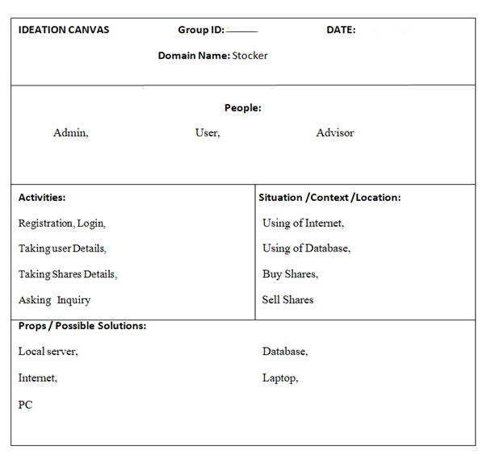
Fig 2.1

Ideation is a process of generating, developing and creating new ideas.

This idea is understood as a basic element of thought that can be visual, concrete or abstract.

Ideation is an essential part of design process, both in education and practice.

- It includes:-

- People
- Activities
- Situation/context/location
- Props/possible solution

- People are:-

- Admin
- User
- Advisor

- Activities going on:-

- Registration
- Login
- Taking User Details
- Taking Shares Details
- Asking For Inquiry

- Situation/context/location:-

- Using of Internet
- Using of Database
- Buy Shares
- Sell Shares

- Props/Possible solution:-

- Local server
- Database
- Internet
- Laptop
- PC

  - Product Development Canvas

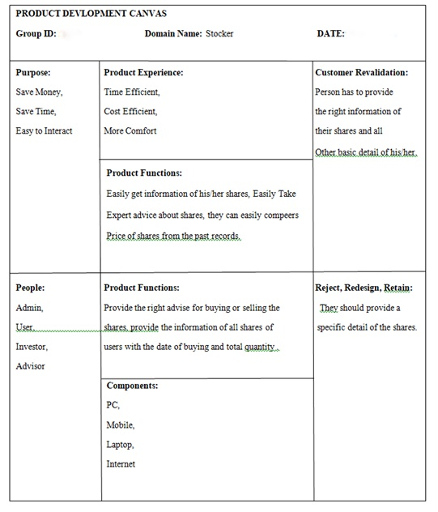
Fig 2.2

Product development is the process of designing, creating, marketing new products or services to benefit customers.

Product design is a prototype mode. The prototype mode is the iterative generation of artifacts intended to answer questions that get you closer to your final solution.

- It includes:-

- Purpose
- People
- Product Experience
- Product function
- Product features
- Components
- Customer revalidation
- Reject , Redesign , Retain

- Purpose:-

- Save Money
- Save Time
- Easy To Interact

- People:-

- Admin
- User
- Investor
- Advisor

- Product Experience:-

- Time Efficient
- Cost Efficient
- More Comfort

- Product Functions:-

- Provide car for renting
- Take online payment

- Product Features:-

- Easily get information of his/her shares,
- Easily Take expert advice about shares,
- They can easily compeers price of shares from the past records
- Components used:-

- PC
- Laptop
- Mobile Phone
- Internet

- Customer Revalidation

- Person has to provide the right information of their shares and all other basic detail of his/her.

- Redesign

- They should provide a specific detail of the shares

  - Dataset Overview

- What is dataset?

Dataset is the basic or unclean data for or machine learning project. It is basically in the form of the .csv file (excel file) .we need to clean our data set for using some basic algorithm

Ex-
- like we need to do fill missing value in the data set
- we need to find mean and then fill that missing values
- or else we can delete that particular entry too
So for our stock market prediction project we need some basic data
Like-
- Open Price
- Closing Price
- Volume
- High For The Day
- Low For The Day

So we can find many raw data for this project but I use Google stock price dataset from kaggel. As well as I am attaching the one photo of our dataset

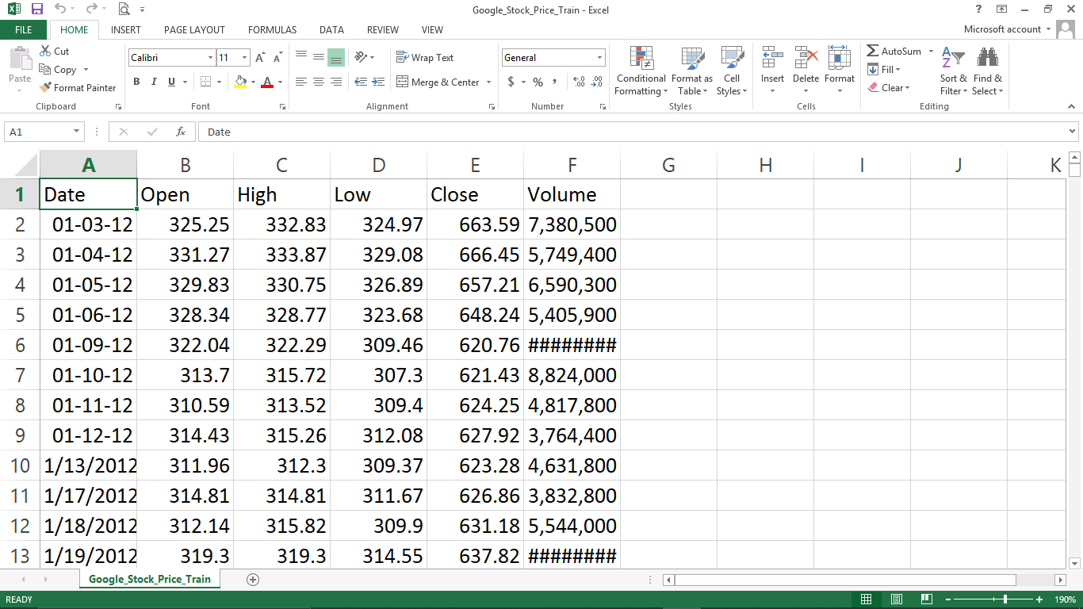

Fig 2.3

  - System Design

- Activity Diagram

An activity diagram is used to model the workflow depicting conditions, constraints, sequential and concurrent activities. On the other hand, the purpose of a Use Case is to just depict the functionality i.e. what the system does and not how it is done.

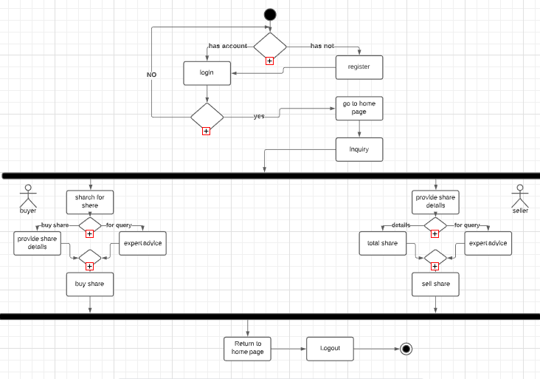
Fig 2.4(a)

- Sequence Diagram

A sequence diagram is a type of interaction diagram because it describes how—and in what order—a group of objects works together. These diagrams are used by software developers and business professionals to understand requirements for a new system or to document an existing process.

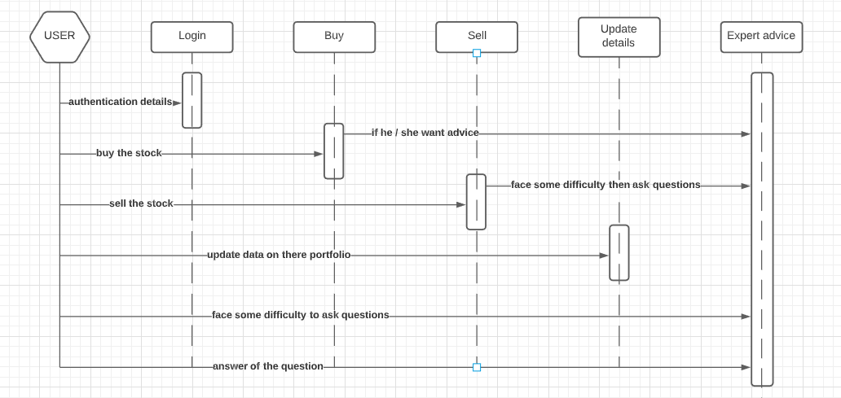
Fig 2.4(b)

- Use Case Diagram

The purpose of the use case diagrams is simply to provide the high level view of the system and convey the requirements in laypeople's terms for the stakeholders. Additional diagrams and documentation can be used to provide a complete functional and technical view of the system.

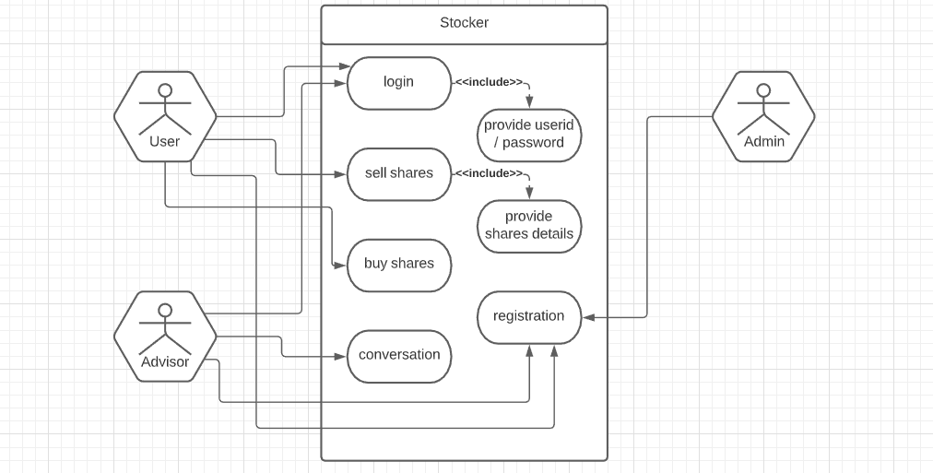
Fig 2.4 (c)
- Class Diagram

A sequence diagram is a type of interaction diagram because it describes how—and in what order—a group of objects works together. These diagrams are used by software developers and business professionals to understand requirements for a new system or to document an existing process.

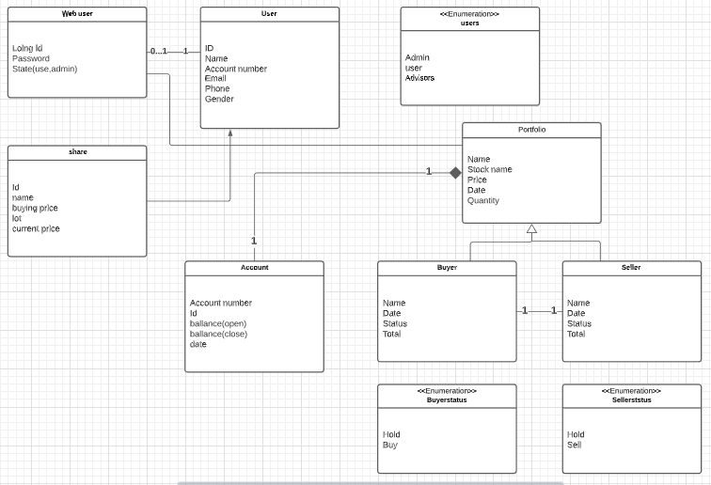
Fig 2.4 (d)

- DFD

A data flow diagram (DFD) maps out the flow of information for any process or system. It uses defined symbols like rectangles, circles and arrows, plus short text labels, to show data inputs, outputs, storage points and the routes between each destination.

- Level 0

A level 0 data flow diagram (DFD), also known as a context diagram, shows a data system as a whole and emphasizes the way it interacts with external entities. This DFD level 0 example shows how such a system might function within a typical retail business.

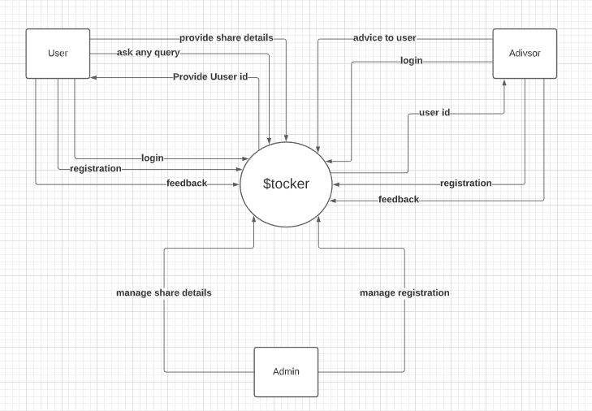
Fig 2.4 (e-1)
- Level 1

A level 1 data flow diagram (DFD) is more detailed than a level 0 DFD but not as detailed as a level 2 DFD. It breaks down the main processes into sub processes that can then be analyzed and improved on a more intimate level.

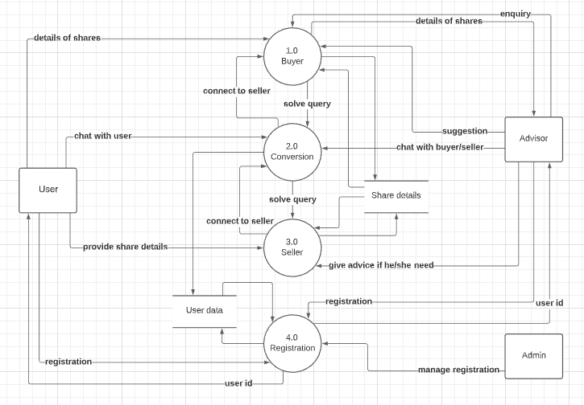
Fig 2.4 (e-2)

3. Implementation
3.1 Implemented Functionality

In this project we created many functionality
- rolling mean for 7days
- comparing original value and predicted value
- graph plotting of particular stock
- dataset information
- Not applicable value return
- Cleaning dataset
- Converting object value in to float
- Model training
So this project is based on stock market prediction using machine learning(stocker) in this project we need to import first basic library of python to do operation on our dataset so using “pandas” library we can import our dataset in our project code then we need to clean our data like filling missing value and deleting the data entry and calculating rolling mean so this is basic functionality in next stage we can plot the graph of that data entries so for this particular project we can plot graph of opening price of the stock then next and very important functionalities we can observe that if there is any not applicable value in the data set column then change our dataset or we need to clean our dataset more so it is main functionality then we need to convert our object value in float so we can easily monitor the value in the third stage of the project we need to calculate 7 day rolling mean so using that we can apply proper algorithm for market prediction after that we will also comparing the original value and 7 day rolling mean in one graph so this is the basic but very important functionality of our project after this the vey most important functionality is to train our machine learning model so for that our machine learning model take hundred input from our dataset after that prediction part we need to check once again if there if any not applicable value then we need to clean it in this part our algorithms create data frame and it take 0 to 60 days as input and predict 61th day output and it will go on after that this is last stage of our project and it is to plot graph of that predicted out vs. original dataset using so we can measure successful ratio of our predicted output this is basic and advanced functionality of our project

3.2 Results and Reports

- Basic code and its results

- Basic Imports

importnumpy as np
importmatplotlib.pyplot as plt
import pandas as pd
importdatetime
fromtensorflow.keras.models import Sequential
fromtensorflow.keras.layers import Dense
fromtensorflow.keras.layers import LSTM
fromtensorflow.keras.layers import Dropout
fromsklearn.preprocessing import MinMaxScaler

- Dataset Import Part

dataset =pd.read_csv (r"C:\Users\HP\data set\Google_Stock_Price_Train.csv",index_col="Date", parse_dates=True)

- Dataset Review
dataset.head()
dataset.tail()
print(dataset)

- Not Applicable Values & Dataset Information

dataset.info()
dataset.isna().any()

- Graph Plotting

dataset['Open'].plot(figsize=(16,6))
dataset['Open'].plot(figsize=(16,6))
dataset.rolling(window=30).mean()['Close'].plot()
dataset['Close: 30 Day Mean'] = dataset['Close'].rolling(window=30).mean()
dataset[['Close', 'Close: 30 Day Mean']].plot(figsize=(16,6))

- Converting Objects Into Float

dataset["Close"] = dataset["Close"].str.replace(',', '').astype(float)
dataset["Volume"] = dataset["Volume"].str.replace(',', '').astype(float)

- Rolling Mean

dataset.rolling(7).mean().head(20)

- Data Frame

training_set=dataset["Open"]
training_set=pd.DataFrame(training_set)

- Model Training

epoch 1/100
1198/1198 [==============================] - 12s 10ms/step - loss: 0.0519
/ /
/ /
epoch 100/100
1198/1198 [==============================] - 6s 5ms/step - loss: 0.0014

- Original Graph Vs Predicted

plt.plot(real_stock_price, color = 'red', label = 'Real Google Stock Price')

plt.plot(predicted_stock_price, color = 'blue', label = 'Predicted Google Stock Price')

plt.title('Google Stock Price Prediction')

plt.xlabel('Time')

plt.ylabel('Google Stock Price')

plt.legend()

plt.show()

  - Snapshots

- Basis Import

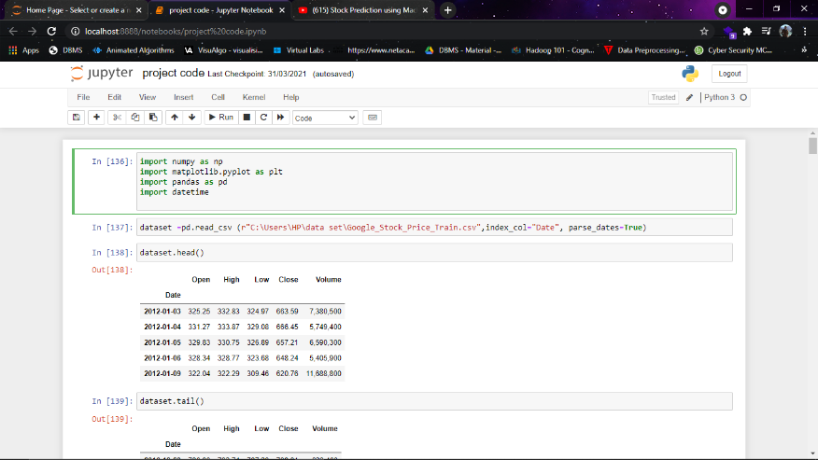

Fig 3.3(a)

- Dataset Load

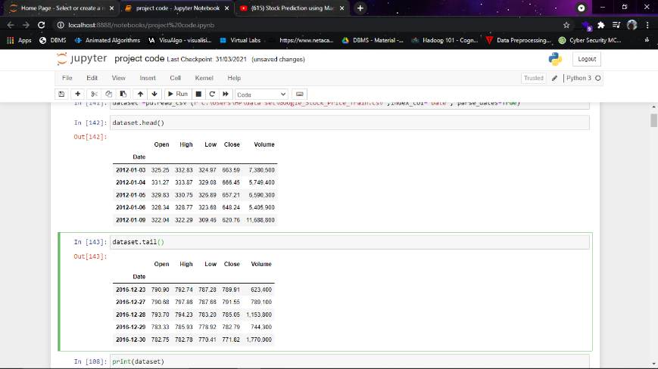

Fig 3.3(b)

- Graph Plotting Of Open Price of Stock (Daily Basis)

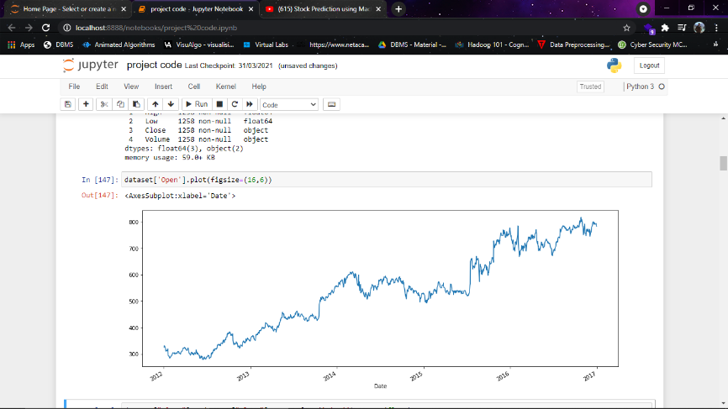

Fig 3.3(c)

- Dataset Information

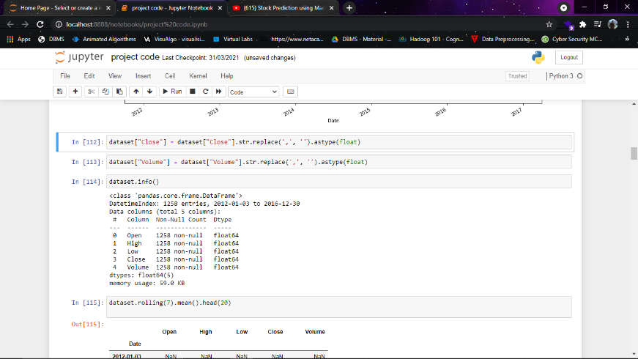

Fig 3.3(d)

- Calculating Rolling Mean

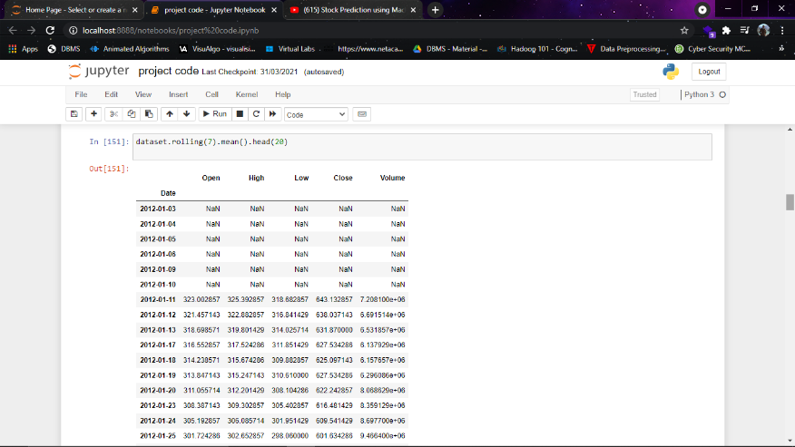

Fig 3.3(e)
- 7 Days Rolling Mean Vs. Original

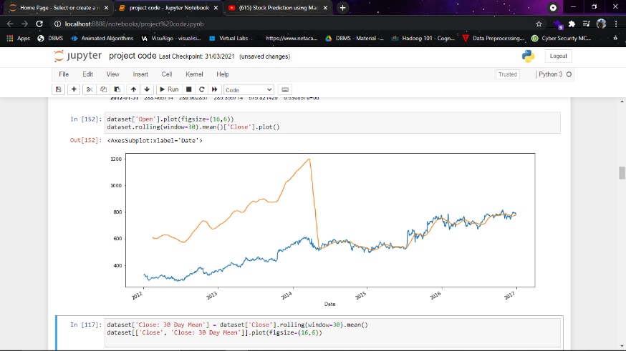

Fig 3.3(f)

- 30 Days Rolling Mean Vs. Original

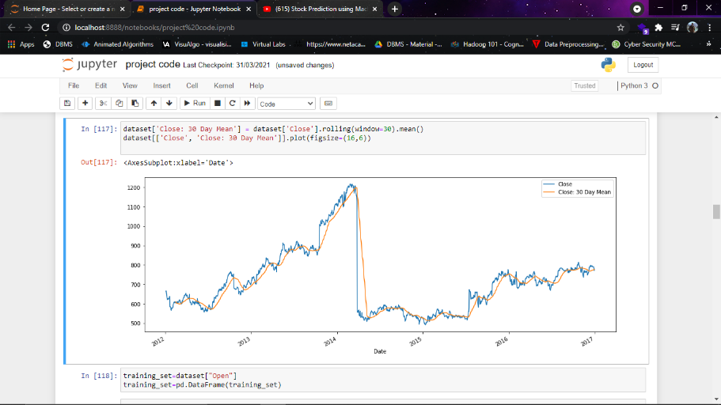

Fig 3.3(g)

- Machine Model Turning

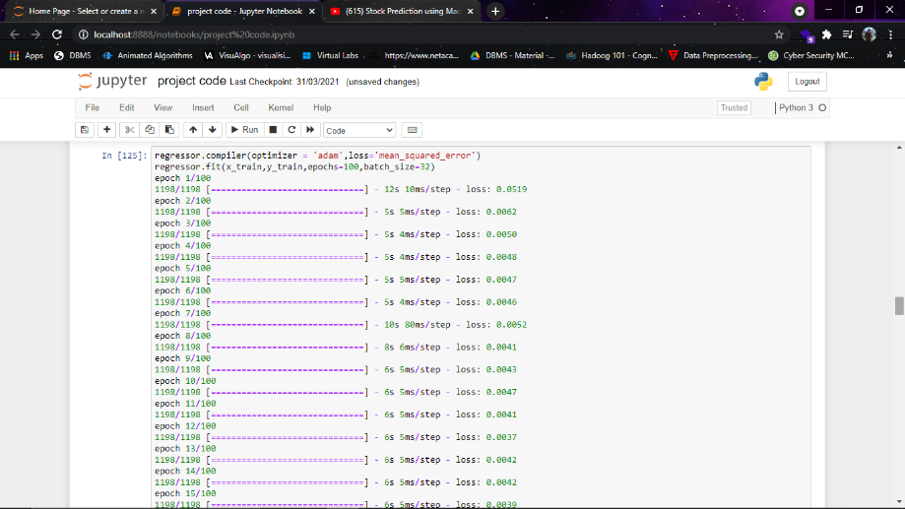

Fig 3.3(h)

- Final Result

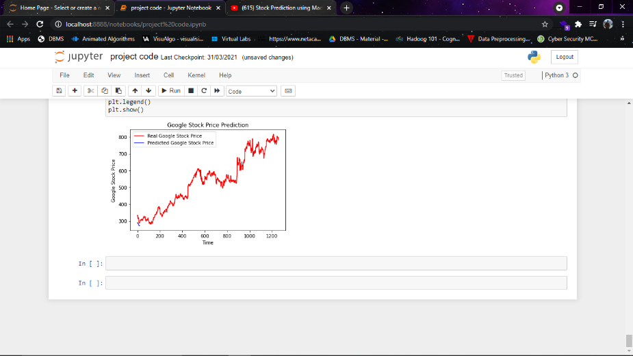

Fig 3.3(i)
  - Testing and Verification

- Testing

  - White box:

White-box testing is a method of testing software that tests internal structures or workings of an application, as opposed to its functionality. In white-box testing an internal perspective of the system, as well as programming skills, are used to design test cases. The tester chooses inputs to exercise paths through the code and determine the appropriate outputs. This is analogous to testing nodes in a circuit, e.g. in-circuit testing (ICT). White-box testing can be applied at the unit, integration and system levels of the software testing process. Although traditional testers tended to think of white-box testing as being done at the unit level, it is used for integration and system testing more frequently today. It can test paths within a unit, paths between units during integration, and between subsystems during a system– level test. Though this method of test design can uncover many errors or problems, it has the potential to miss unimplemented parts of the specification or missing requirements.

  - Black Box:

Black box testing is a method of software testing that examines the functionality of an application without peering into its internal structures or workings. This method of test can be applied virtually to every level of software testing: unit, integration, system and acceptance. It typically comprises most if not all higher level testing, but can also embody unit
From testing perspective:
- Fault – wrong or missing function in the code.
- Failure – the manifestation of a fault during execution.
- Malfunction – according to its specification the system does not meet its specified functionality.

- Software Verification

Software Verification: The process of evaluating software to determine whether the products of a given development phase satisfy the conditions imposed at the start of that phase. Software verification is ensuring that the product has been built according to the requirements and design specifications.

- Software Validation

- Software Validation: The process of evaluating software during or at the end of the development process to determine whether it satisfies specified requirements.
- Software validation ensures that the product meets the user's needs, and that the specifications were correct in the first place. Software verification ensures that "you built it right". Software validation ensures that "you built the right thing". Software validation confirms that the product, as provided, will fulfill its intended use.

Thus for our project we verified that:
- Application provides all the functionalities to the user to buy books online with ease.
- We validate that the user puts all correct information for registration & login purpose so that data integrity is maintained.
- Also we validate Design in different mobiles so that there might be no changes in the GUI of the application

- Conclusion
  - Summary of the results
We are developing one website of machine learning project through which we can predict the future price of the stock market using frontend, backend an as well as graph plotting and also we will use mySQL or SQlite or any other dataset for storing the data and to host the website we are using Gunicorn server.We are also providing some advanced level features so that trading can be done directly by them from here.

  - Advantages of your work/results/methodologies
We visited many websites for this project like stock price forecasting, stock prediction in python etc and we saw that in all websites stocks price keeps updating from their native websites time to time so we concluded that we will show market price in our website and give proper advice to user form some market experts. We also visited some websites for making home page and another pages of our website like money control, news api etc and we notice that in all the websites they saw some basic information in their homepage so we concluded to show some basic details like about us, about our project, login etc and keep one suggestion box if anyone can give us advice to saw more details in our websites.

  - Scope of future work

If our software runs successfully than using Django and live web scrapping we can do deployment.
Live data fetch can be done in Tiingo and through that we can also predict the future price of the stock market.

  - Attainment of POs and PSOs

PO / PSO | Attainment Level | Justification
PO1 | 2 | Our system is a Web portal: so computer related knowledge is applied and it is functioning with a database and it is a related concept.
PO2 | 0 | Engineering problems are not related to our system.
PO3 | 2 | It meets the specific requirements of the particular user and helps to solve the problems that he/she is facing currently.
PO4 | 2 | Data will be provided to the system, it will be interpreted according to how that system will function.
PO5 | 2 | We used Django as well as flask and also used Gunicorn server
PO6 | 3 | User is required to select which company he is interested in amongst companies that have been provided.
PO7 | 2 | Web hosting makes the file that comprise a website available for viewing online and hosted on a server.
PO8 | 1 | Jupyter notebook is used to combine code,output and multimedia resources in a single document.
PO9 | 2 | Data analysis tools like Tiingo are also used to create API’S and also data fetch.
PO10 | 3 | Fundamental indicators like price to earning ratio and cash flow ratio by which company’s stock value can be predicted.
PO11 | 2 | The Admin is maintaining the whole system and he is there to see the workflow.
PO12 | 1 | In Future,like any complex problem, it has far too many variables to be predicted.
PSO1 | 3 | By developing this System, we get to know how the real time project is supposed to be done. What are the challenges we faced while developing the system. We did not know how the analysis could be done but by doing the project, we had enough knowledge about all this stuff.
PSO2 | 2 | We had faced many things that we did not know how to do. We have to use more updated technology in order to compete in the real time market.

Appendix A – Business Model Canvas (BMC)
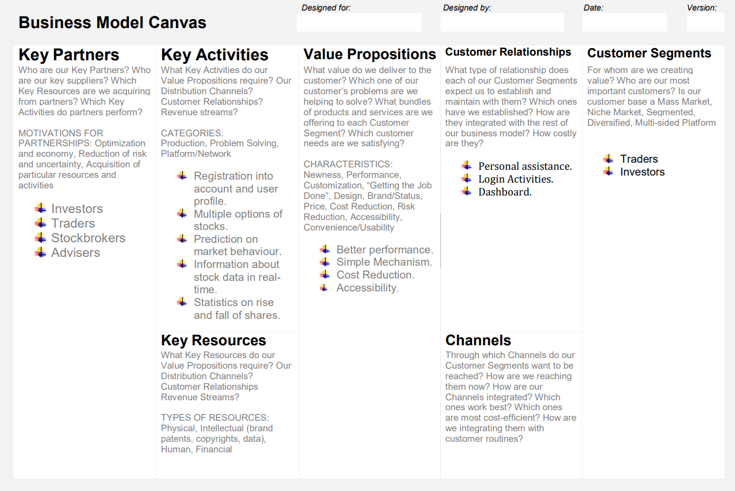
Fig 5(a)
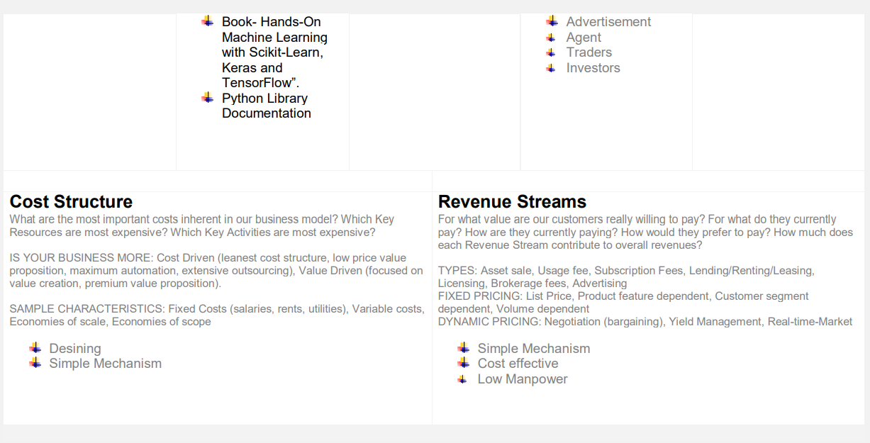
Fig 5(b)

- Key Partners
- Investors
- Traders
- Stockbrokers
- Adviser

- Key Activities
- First you need to register yourself so you can see your profile.
- User can see all the available options for every share.
- User can predict the share price after seeing the market behaviour.
- User can get all the information about stock data in real-time.
- User can see all the statistics of rise and fall share so it is useful for user to invest in shares.

- Value Propositions
- User likes to use it because the performance is the better.
- The main benefit for the user is it having a simple mechanism so it is very helpful for user.
- The system cost is very low (Cost Reduction).
- The accessibility of the system is very easy it is very easy to access.

- Customer Relationship
- User can opt for the personal assistance option for investing their money into shares.
- From login user can view all the login activities which is done by the user.
- From Dashboard user can view the entire shares price.

- Customer Segments
- Traders
- Investors

- Key Resources
- Book-hands-on Machine Learning with scikit-Learn, keras and TensorFlow.
- Python Library Documentation.

- Channels
- Advertisement
- Agent
- Traders
- Investors

- Cost Structure
- Designing is very simple so it cost us.
- The mechanism is so simple so user can use it without any difficulties.

- Revenue Streams
- The mechanism is simple.
- Cost Effective.
- Low Manpower.

Appendix B – Periodic Progress Reports (PPR)
- Periodic Progress Report 1

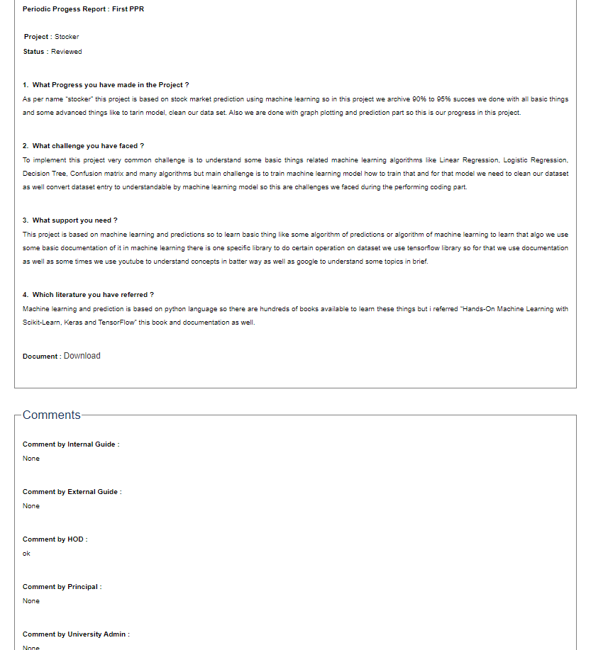
Fig 6(a)

1. What Progress you have made in the Project ?
As per name “stocker” this project is based on stock market prediction using machine learning so in this project we archive 90% to 95% succes we done with all basic things and some advanced things like to tarin model, clean our data set. Also we are done with graph plotting and prediction part so this is our progress in this project.

2. What challenge you have faced ?
To implement this project very common challenge is to understand some basic things related machine learning algorithms like Linear Regression, Logistic Regression, Decision Tree, Confusion matrix and many algorithms but main challenge is to train machine learning model how to train that and for that model we need to clean our dataset as well convert dataset entry to understandable by machine learning model so this are challenges we faced during the performing coding part.

3. What support you need ?
This project is based on machine learning and predictions so to learn basic thing like some algorithm of predictions or algorithm of machine learning to learn that algo we use some basic documentation of it in machine learning there is one specific library to do certain operation on dataset we use tensorflow library so for that we use documentation as well as some times we use youtube to understand concepts in batter way as well as google to understand some topics in brief.

4. Which literature you have referred ?
Machine learning and prediction is based on python language so there are hundreds of books available to learn these things but i referred “Hands-On Machine Learning with Scikit-Learn, Keras and TensorFlow” this book and documentation as well.

- Periodic Progress Report 2

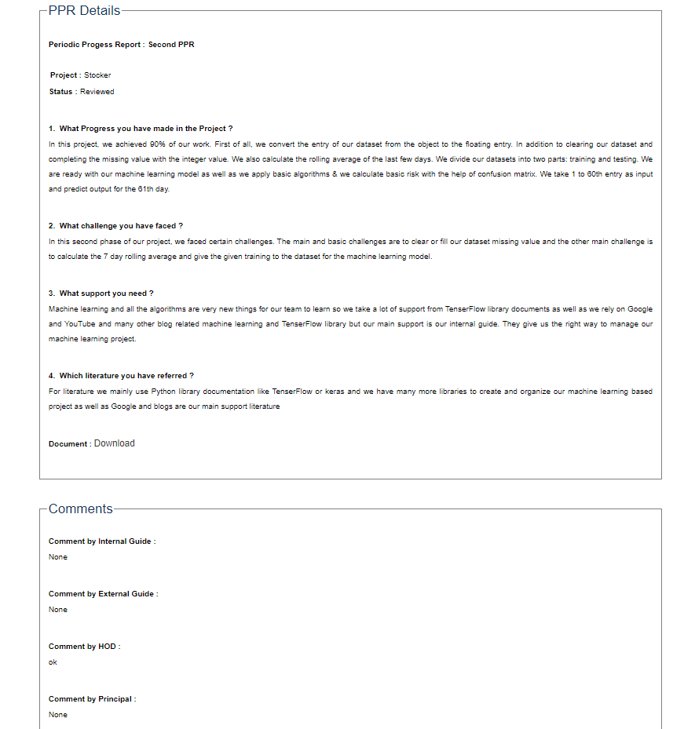
Fig 6(b)

1. What Progress you have made in the Project ?
In this project, we achieved 90% of our work. First of all, we convert the entry of our dataset from the object to the floating entry. In addition to clearing our dataset and completing the missing value with the integer value. We also calculate the rolling average of the last few days. We divide our datasets into two parts: training and testing. We are ready with our machine learning model as well as we apply basic algorithms & we calculate basic risk with the help of confusion matrix. We take 1 to 60th entry as input and predict output for the 61th day.

2. What challenge you have faced ?
In this second phase of our project, we faced certain challenges. The main and basic challenges are to clear or fill our dataset missing value and the other main challenge is to calculate the 7 day rolling average and give the given training to the dataset for the machine learning model.

3. What support you need ?
Machine learning and all the algorithms are very new things for our team to learn so we take a lot of support from TenserFlow library documents as well as we rely on Google and YouTube and many other blog related machine learning and TenserFlow library but our main support is our internal guide. They give us the right way to manage our machine learning project.

4. Which literature you have referred ?
For literature we mainly use Python library documentation like TenserFlow or keras and we have many more libraries to create and organize our machine learning based project as well as Google and blogs are our main support literature

- Periodic Progress Report 3

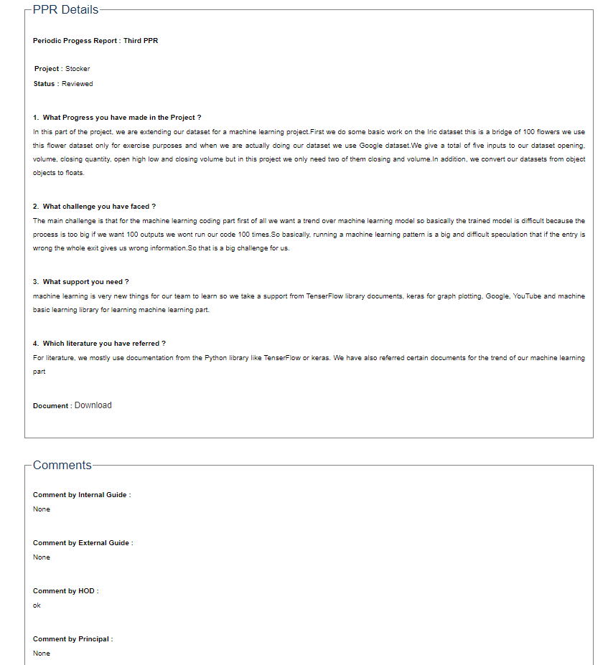
Fig 6(c)

1. What Progress you have made in the Project ?
In this part of the project, we are extending our dataset for a machine learning project.First we do some basic work on the Iric dataset this is a bridge of 100 flowers we use this flower dataset only for exercise purposes and when we are actually doing our dataset we use Google dataset.We give a total of five inputs to our dataset opening, volume, closing quantity, open high low and closing volume but in this project we only need two of them closing and volume.In addition, we convert our datasets from object objects to floats.

2. What challenge you have faced ?
The main challenge is that for the machine learning coding part first of all we want a trend over machine learning model so basically the trained model is difficult because the process is too big if we want 100 outputs we wont run our code 100 times.So basically, running a machine learning pattern is a big and difficult speculation that if the entry is wrong the whole exit gives us wrong information.So that is a big challenge for us.

3. What support you need ?
machine learning is very new things for our team to learn so we take a support from TenserFlow library documents, keras for graph plotting, Google, YouTube and machine basic learning library for learning machine learning part.

4. Which literature you have referred ?
For literature, we mostly use documentation from the Python library like TenserFlow or keras. We have also referred certain documents for the trend of our machine learning part

- Periodic Progress Report 4

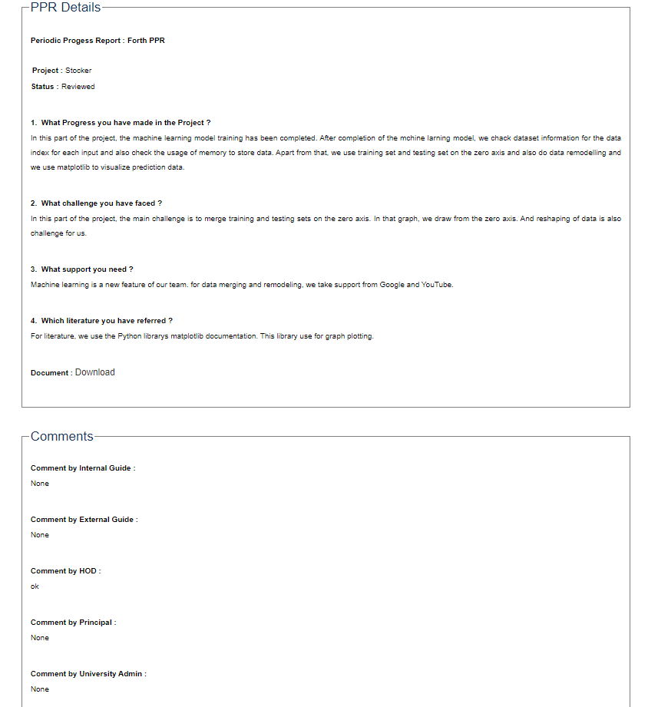
Fig 6(d)

1. What Progress you have made in the Project ?
In this part of the project, the machine learning model training has been completed. After completion of the mchine larning model, we chack dataset information for the data index for each input and also check the usage of memory to store data. Apart from that, we use training set and testing set on the zero axis and also do data remodelling and we use matplotlib to visualize prediction data.

2. What challenge you have faced ?
In this part of the project, the main challenge is to merge training and testing sets on the zero axis. In that graph, we draw from the zero axis. And reshaping of data is also challenge for us.

3. What support you need ?
Machine learning is a new feature of our team. for data merging and remodeling, we take support from Google and YouTube.

4. Which literature you have referred ?
For literature, we use the Python librarys matplotlib documentation. This library use for graph plotting.

Appendix C – Patent Drafting Exercise (PDE)

Form 1 – APPLICATION FOR GRANT OF PATENT
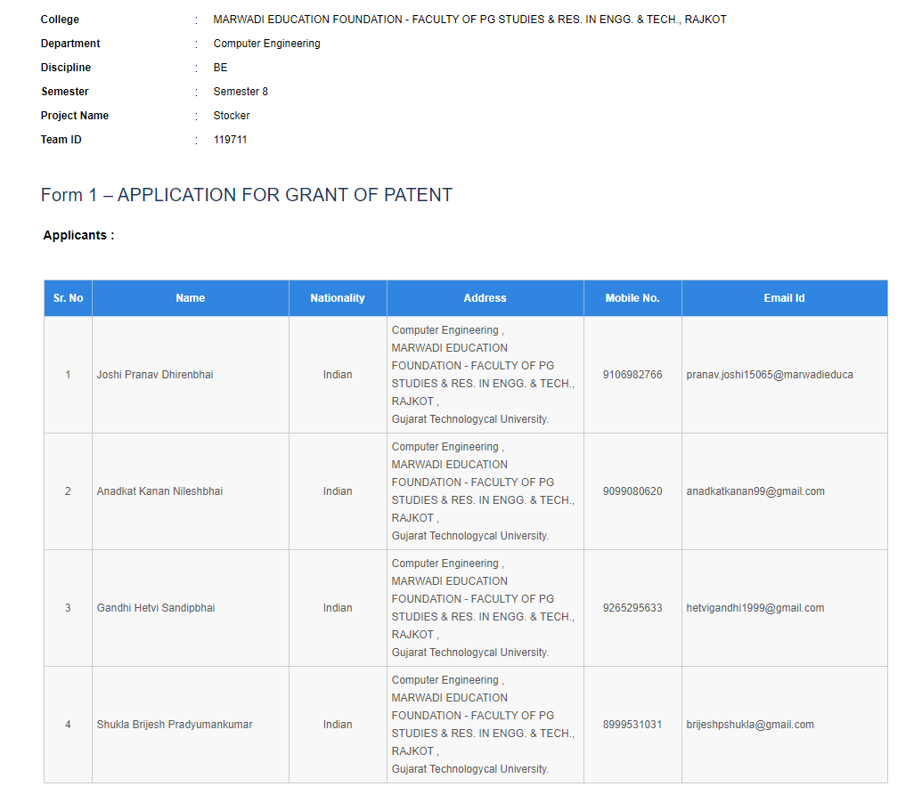
Fig 7(a-1)

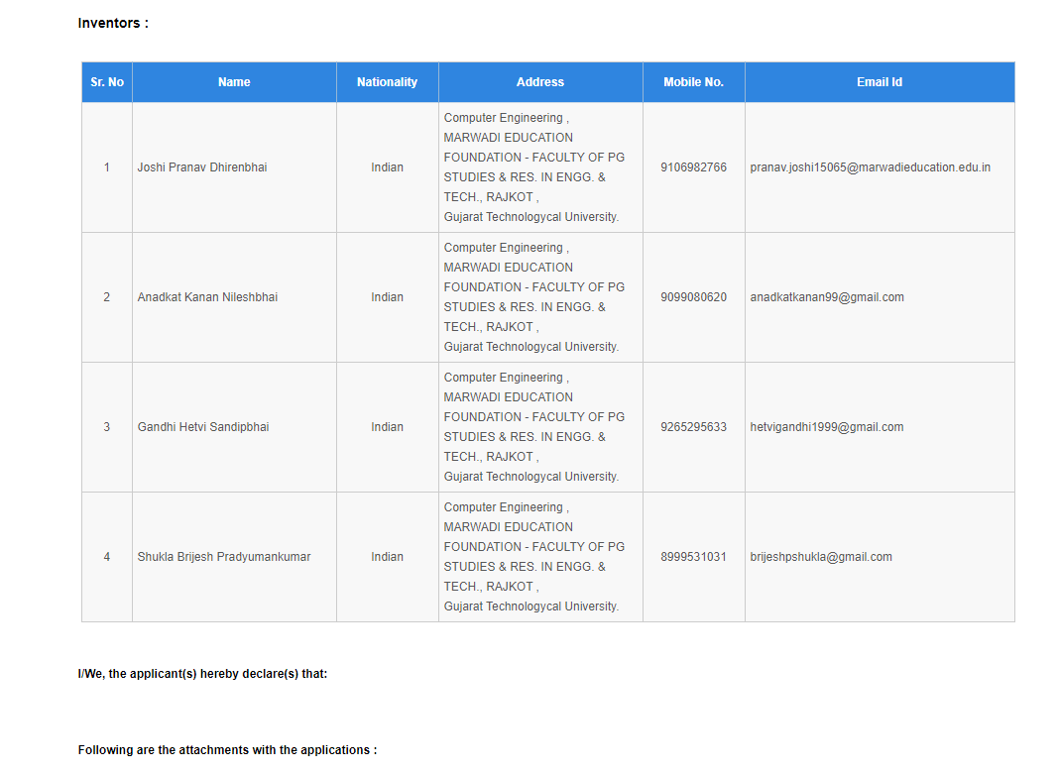

Fig 7(a-2)

Form 2 - PROVISIONAL/COMPLETE SPECIFICATION
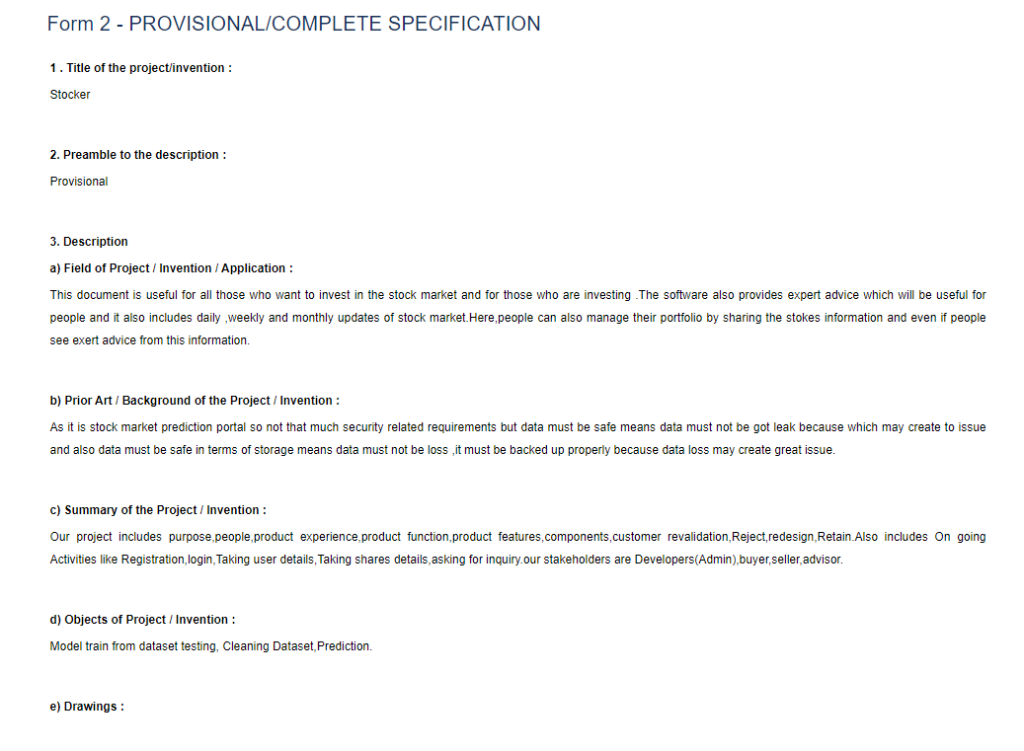
Fig 7(b-1)

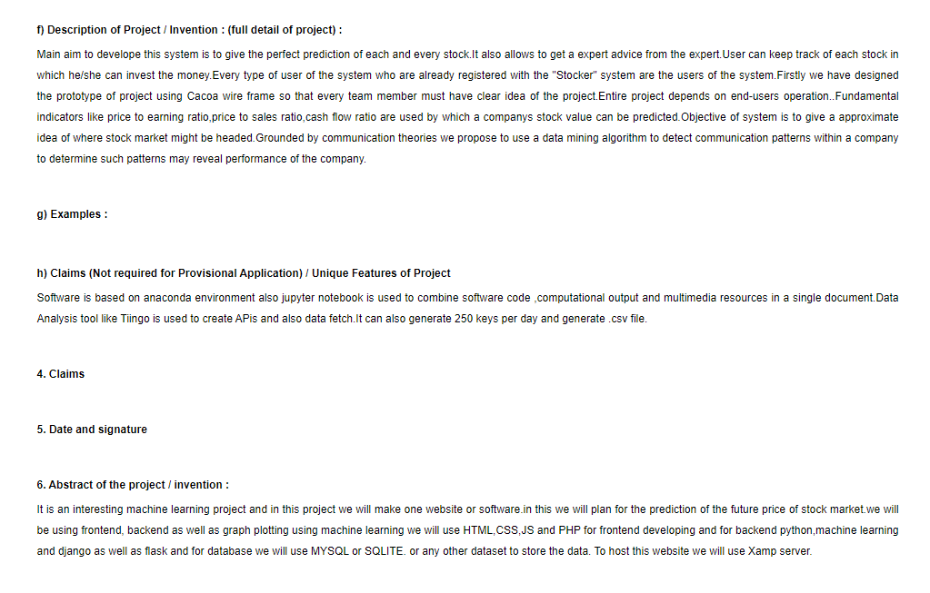
Fig 7(b-2)

Form 3 – STATEMENT AND UNDERTAKING UNDER SECTION 8

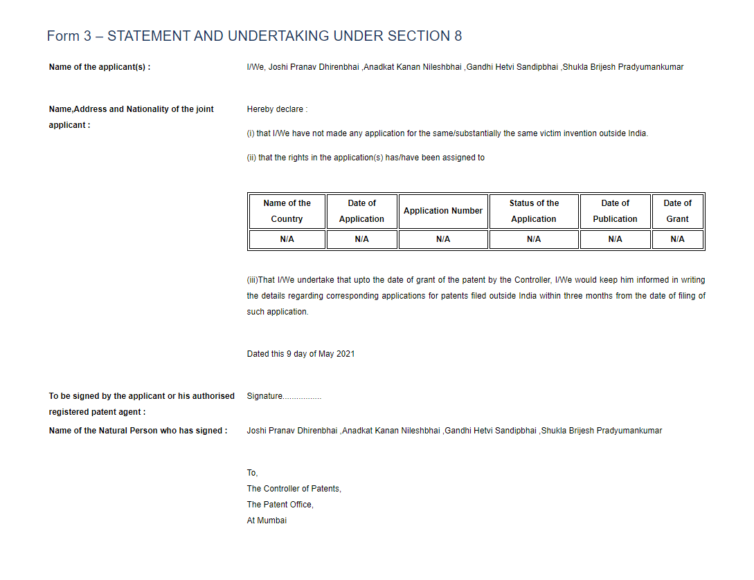
Fig 7(c)

Appendix D – Plagiarism Report
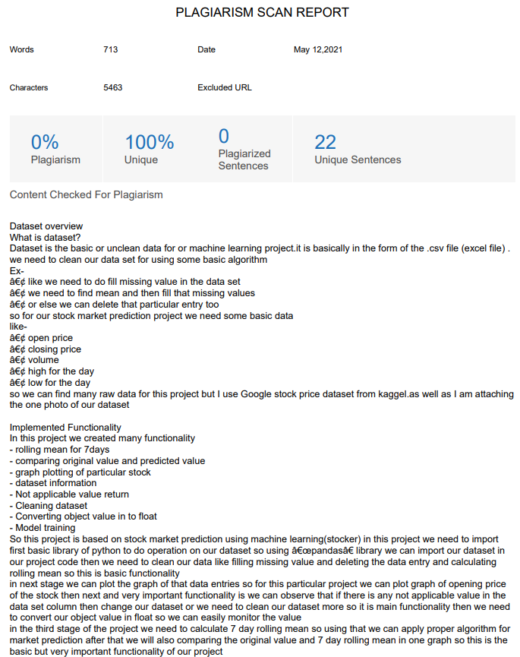
Fig D

